Dechorionation SOP

Dechorionation is the process of removing the chorion of an embryo.
Start time: At 1pm (Why? Because the embryos are roughly 6hpf)
Duration: approximately 1 hour.
Overview: Automatic dechorionation is broken up into 2 parts. The first part (the complete cycle) that takes 19.5 minutes and the second part (the rinse cycle) that takes 6 minutes. There is a 30 minute rest in between the two parts.

Part 1: The complete cycle
- Gather all 30ml tubes of embryos that are to be dechorionated. Only four vials can be
of dechorionation can be done at one time. Double check to make sure that Embryo Medium water level is at 25ml mark for each tube.

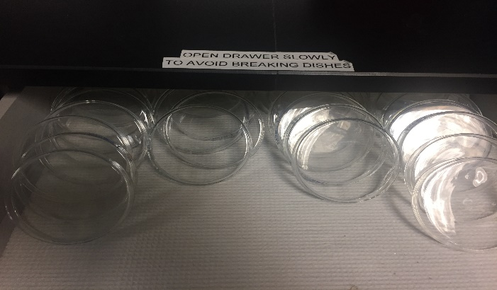
- Placeclean glass petri dishes on the stage of dechorionator. The glass petri dishes can be found against the back wall bench of the common lab area. Use one glass petri dish per vial of embryos to be dechorionated.
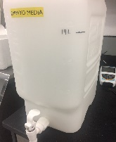
- Take out 5 gallon carboy of Embryo Medium (EM) water from warm room and set under dechorionator. Place black tube (from Dechorionator) into EM carboy and make sure it reaches the bottom of the container. Make sure there is at least 1 gallon of EM remaining in carboy for Dechorionation

- Procure pronase aliquot from -80 freezer. The pronase aliquots can be found in the -80 freezer in the back hallway, bottom cabinet. Use one pronase aliquot per 30ml tube of embryos to be dechorionated.
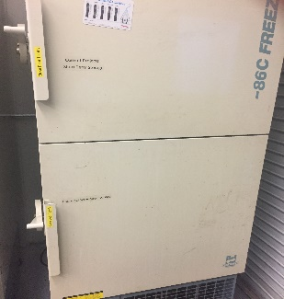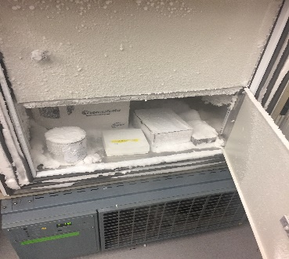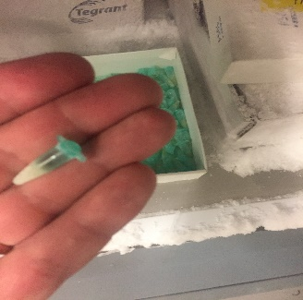
- After pronase aliquot has thawed, spin down aliquot and add 83ul of pronase to each dry glass petri dish with 200ul pipetter.
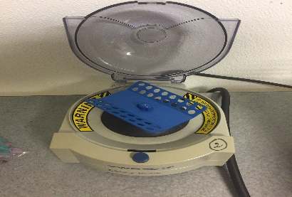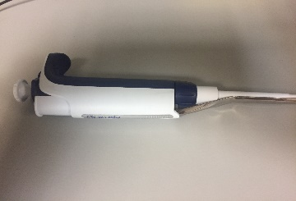

- Making sure embryos are not settled at the bottom of the vial by gently rocking tube of embryos back and forth. Make sure lid is secure! Then gently pour one vial of embryos into one glass petri dish.
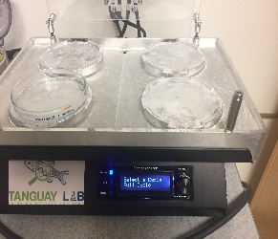
- Hit start and follow steps until dechorionator starts moving.
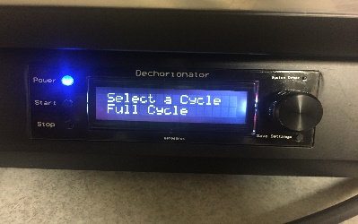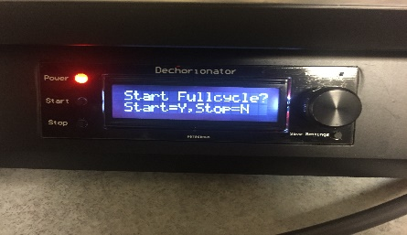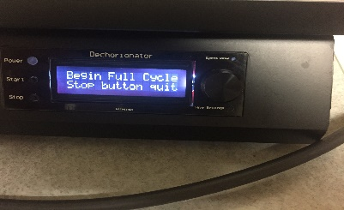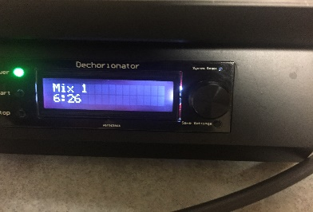
- At 19.5 minutes, the first cycle is complete. The dechorionator will prompt you to hit “stop” button to start countdown “incubation” rest period. Carefully decant 50% of water of each dish. Be careful so as not to allow embryos to stick to dish while decanting. Put petri dishes with embryos into the incubator for 30 minutes to rest. Do not shake petri dishes. Set timer for 30 minutes. If you walk away from the dehorionator, take timer with you. 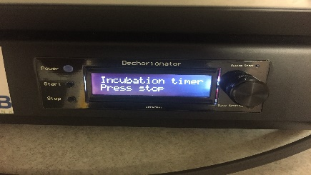

Part 2: The rinse cycle
- After the 30 minutes of rest, take the petri dishes out of the incubator and provide manual gentle motion for about 20 seconds/dish. (Why? To help remove chorions, but gently, as not to damage the embryos from the force)
- Put dishes back on dechorionator. And follow instructions on the lcd screen to start rinse cycle.
- After rinse cycle is complete, remove dish and decant water. Screen dish and remove any non-usable embryos (e.g. still-chorionated embryos, dead/overdigested embryos)
- Embryos are ready to plate!

